Peter Sanford

IT 2700  
NetLab Lab 16  
10/14/2023

1:

Step 7:

Step 18:

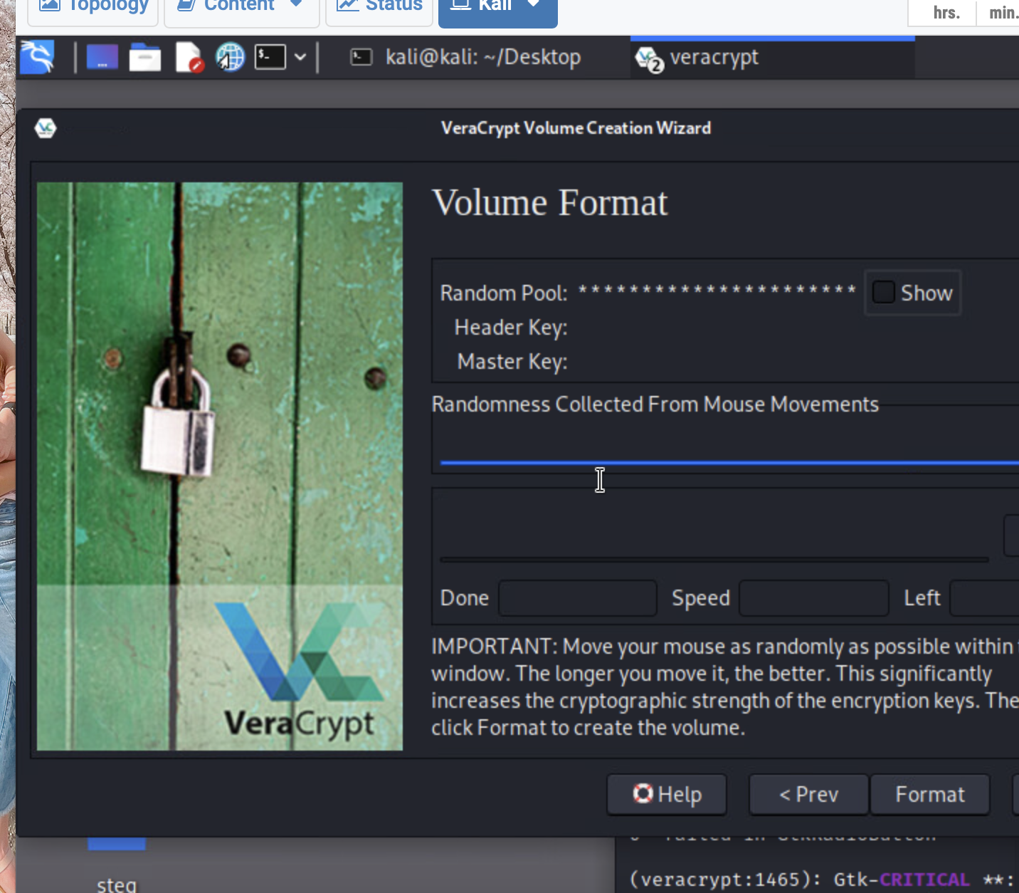

Step 21:

2:

Step 6:

Step 12:

Commentary:

In this lab we looked at encrypting a file system with software. This software setup an encrypted drive with a password, and anything saved in it passes through a cryptographic algorithm. I learned that a lot of things can use cryptography and can be used in many instances. It can secure networks, stored files, basically any binary at all. Companies can use this information to secure their information in any form they want. They do need to keep in mind though the balance between convenience and security.